* font-family: ”Arial”
* font-size: 200px(for pixel)/ 2em(its double the size of parent element)
* font-weight: bold /100 to 800(we can only do every 100 number like 100,200 etc)
* line-height: 1.5
* text-align: center/right/left etc.
* text-decoration: underline/line-through

l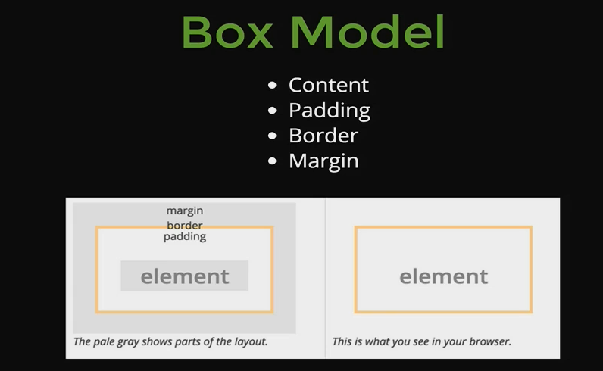

* Picture explains it. One trick is margin: 0 auto (0 auto 0 auto to be exact) to center an element.
* **Margin Collapsing:**

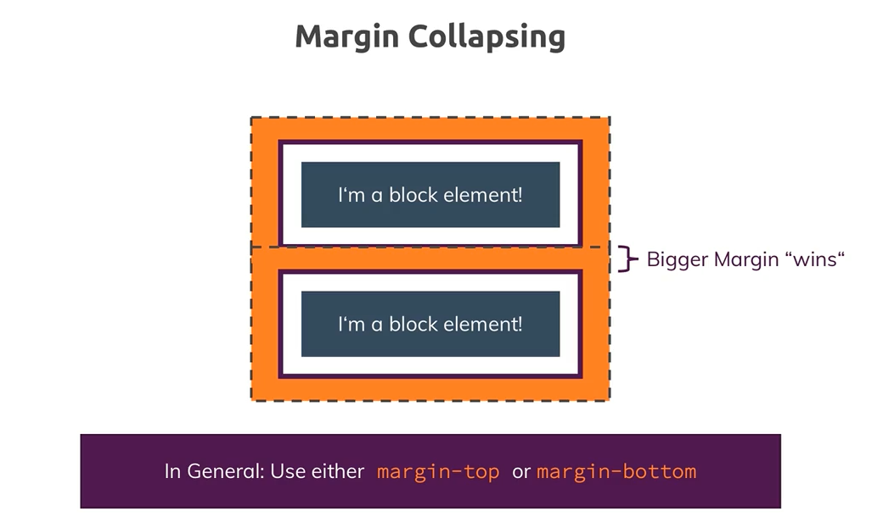

If two adjacent elements have margins overlapping, the bigger margin wins. This is known as margin collapsing.

* **Box-Sizing:**

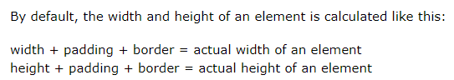

As a result, our elements will appear bigger cause it will add the padding and border. To solve this, we can use **box-Sizing: Border-box.** Its safe to actually assign it to whole document as a css rule. Border box means the height will include the padding and the border

